**Human Resource Management System**

**A Project Report**

Submitted in partial fulfillment of the

Requirements for the award of the Degree of

**BACHELOR OF SCIENCE (INFORMATION TECHNOLOGY) By**

**Sayali Sujit Mungekar**

**Seat Number** –:4021171

**Under the esteemed guidance of**

**Mrs. Medha Sahasrabuddhe**

**Assistant Professor at Information Technology**

**Department of Gogate Jogalekar College,**

**Ratnagiri**



**DEPARTMENT OF INFORMATION TECHNOLOGY**

**GOGATE JOGALEKAR COLLEGE, RATNAGIRI**

***(Affiliated to University of Mumbai)***

**RATNAGIRI, 415612**

**MAHARASHTRA**

**2022-23**

# PROJECT PROPOSAL

**P.R.N. Number:** 2020016400848494 **Roll No.** TTA- 18

1. **Name of the Student :**  Sayali Sujit Mungekar
2. **Title of the Project:**  Human Resource Management System.
3. **Name of the Guide :** Mrs. Medha Sahasrabuddhe
4. **Teaching experience of the Guide-** 9 years
5. **Is this your first submission?**  Yes /  No

**Signature of the Student** **Signature of the Guide**

**Date: Date:**

**Signature of the Coordinator**

**Date:**

### GOGATE JOGALEKAR COLLEGE, RATNAGIRI

***(Affiliated to University of Mumbai)***

### RATNAGIRI-MAHARASHTRA-415612

**DEPARTMENT OF INFORMATION TECHNOLOGY**



**CERTIFICATE**

This is to certify that the project entitled, **"HUMAN RESOURCE MANAGEMENT SYSTEM"**, is bonafide work of **SAYALI SUJIT MUNGEKAR** bearing Seat.No: **(4021171)** submitted in partial fulfillment of the requirements for the award of degree of BACHELOR OF SCIENCE in **INFORMATION TECHNOLOGY** from **University of Mumbai.**

#### Internal Guide Coordinator / HOD

#### External Examiner

**Date: College Seal**

**DECLARATION**

I hereby declare that the project entitled, “**HUMAN RESOURCE MANAGEMENT SYSTEM”** done at **Gogate Jogalekar College, Ratnagiri**, has not been in any case duplicated to submit to any other University for the award of any degree. To the best of my knowledge other than me, no one has submitted to any other University.

The project is done in partial fulfillment of the requirements for the award of degree of **BACHELOR OF SCIENCE (INFORMATION TECHNOLOGY)** to be submitted as final semester project as part of our curriculum.

**SAYALI SUJIT MUNGEKAR**

# ABSTRACT

The “HUMAN RESOURCE MANAGEMENT SYSTEM “ has been developed to override the problems prevailing in the practicing manual system.

Every Organization, whether big or small has challenges to manage the information of employee in large extend. This **“HUMAN RESOURCE MANAGEMENT SYSTEM”** will allow the HR manager to manage the employee information, employee recruitment, employee training.

The main purpose of this system is to automate its existing manual system by the help of computerized equipment and full-fledged computer software, fulfilling the requirements of company so that their valuable data can be stored for a longer period with easy accessing and manipulation of the same.

**ACKNOWLEDGEMENT**

I would like to thank Prof. Mrs. Medha Sahsrabuddhe for providing me an opportunity to work on this project and giving me guidelines to present the project and to expand my knowledge. Her valuable guidance and support helped me to carry out the project work successfully. It helps me to realize that of what we study for.

I also wish to express my sincere thanks to HOD of the Department of Information Technology Mrs. Medha Sahsrabuddhe, Co-ordinator Dr.Vivek Bhide, Vice Principal Dr. Aparna Kulkarni and Principal of Gogate Joglekar College Dr. Prafulladatta Kulkarni for their support and the facilities they have made available. I am also grateful to the staff of department of Information Technology for their consistent support and assistance.

Then I would like to thank my parents and friends who helped me through the project with their valuable guidance.

**Table of Content:**

|  |  |  |
| --- | --- | --- |
| **Sr. No** | **Index** | **Page No.** |
| **1.** | **Introduction** | **10-11** |
|  | 1.1.Background | 10 |
|  | 1.2.Objectives | 10 |
|  | 1.3.Purpose,Scope and Applicability | 10 |
|  | 1.3.1 Purpose | 10 |
|  | 1.3.2.Scope | 10 |
|  | 1.3.3.Applicability | 11 |
| 2. | **System analysis** | **12-13** |
|  | 2.1.Exsiting System | 12 |
|  | 2.2.Proposed System | 12 |
|  | 2.3.Requirement analysis | 12 |
|  | 2.3.1 Software Requirements | 12 |
|  | 2.3.2.Hardware Requirements | 12 |
|  | 2.4 Planning And Scheduling-Gantt chart | 13 |
| 3. | **System Design** | **14-28** |
|  | 3.1 Modules | 14 |
|  | 3.2 Database | 15-17 |
|  | 3.3.Figures | 18-25 |
|  | 3.4 User Interface Design | 26-28 |

|  |  |  |
| --- | --- | --- |
| **Sr.No.** | **Index** | **Page No.** |
| **4.** | **Implementation and Testing** | **29-31** |
|  | 4.1 Code | 29-30 |
|  | 4.2 Test Cases | 31 |
| **5.** | **Result and discussion** | **32-33** |
| **6.** | **Conclusion** | **34** |
| **7.** | **Reference** | **35** |

**LIST OF FIGURES:**

|  |  |  |
| --- | --- | --- |
| **SR**  **No.** | **Figure Name** | **Page No** |
| 1. | Fig1 : E-R Diagram | 18 |
| 2. | Fig2 : Activity Diagram | 19 |
| 3. | Fig 3: Sequence Diagram | 21-22 |
| 4. | Fig4 : Use-case Diagram | 23-24 |
| 5. | Fig5 :Class Diagram | 25 |

## LIST OF TABLES:

|  |  |  |
| --- | --- | --- |
| **Sr. No.** | **Figures** | **Page No.** |
| 1. | Login | 15 |
| 2. | Recruitment | 15 |
| 3. | Post | 16 |
| 4. | Department | 16 |
| 5. | Employee | 16 |
| 6. | Training | 17 |
| 7. | Salary | 17 |

**INTRODUCTION**

* 1. **Background:**

As your team gets bigger, so does the problem of managing them. It becomes a struggle to get a single view of employee data. Sensitive workforce information will remain splattered across multiple folders or systems that don’t play well with each other. It demands too much manual effort to stay intact. As a result, the efficiency of HR processes drops dramatically.

HR tasks are too complex and time-consuming when performed manually. With the help of a technological solution like an HRMS can help you save time and manage your staff better.

**1.2Objectives:**

The Human Resource Management System (HRMS) aims to manage employee’s information. HRMS is the most important because it provides systematic and accurate information about the employees of the organization.

So HRMS objective are as following:-

1. Manage the recruitment process

2. Store the details of employee in database

3. Schedule proper training of employee

4. Maintain salary record.

5. Keep the record of departmental Posts and vacancies.

**1.3 Purpose, Scope and Applicability**

**1.3.1Purpose**

To help company to manage Recruitment, Designation ,Training and salary of an employee in effective manner which also saves time of an HR manager to keep records of employee and to handle each daily task in an productive manner.

**1.3.2 Scope:**

The main function of an HR Management System is to standardize and consolidate the core processes related to Human Resource Management.

**1.3.3. Applicability:**

This System is applicable to HR Manager of a company. All the task which HR Manager used to do manually which increases time complexity, this system will overcome that problem in productive manner.

**2. SYSTEM ANALYSIS**

**2.1 EXISTING SYSTEM:**

Existing System consists lack of security of data. All the work of HR Manager requires more man power. As all the tasks were used to carry out manually on paper by HR Manager of the company it consumes more time and cost. This problems are overcome in Proposed System.

**2.2 PROPOSED SYSTEM:**

Proposed system will provide better service than Existing System. The system works properly with full availability, reliability, security and safety. It contains greater efficiency, security of data with data accuracy. As there is less amount of manual work this system will also consume time. System stores all the details of employee in the database so that the HR manager can retrieve it anytime when organization needs it.

**2.3 REQUIREMENT ANALYSIS:**

**2.3.1 User Requirements:**

User requirements include minor details, but most importantly users must be aware that the system works properly with full availability, reliability, security and safety. The user (HR Manager) responsibility is as follows: User (HR Manager) should know how to use the application and should adhere to the guidelines and prescribed standards.

**2.3.2 Development Requirements:**

**2.3.2.1** **Software Requirements:**

1. Visual Studio.

2. Microsoft SQL Server Database.

**2.3.2.2 Hardware Requirements:**

1. Disk space:160 MB free as much as you need to store materials.

2. Backups: To keep backup of the site.

3. Memory : 256 Mb(min).

4. PC with 4GB Ram

**2.4 PLANNING AND SCHEDULING-GANTT CHART:**

**Gantt chart 1 (Expected)**

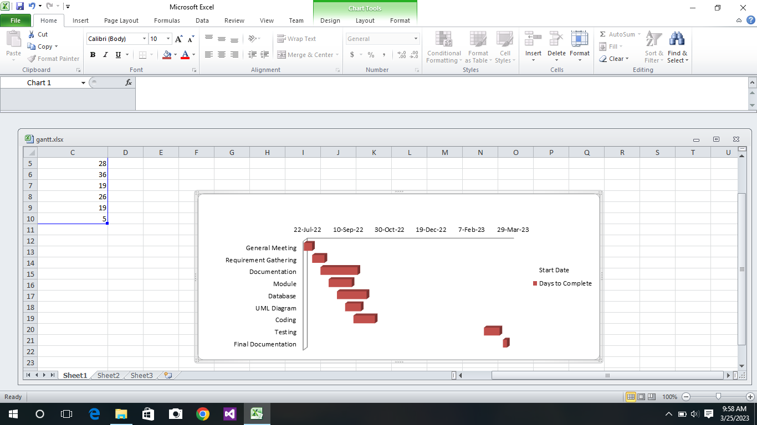

**Gantt chart 2 (Actual)**

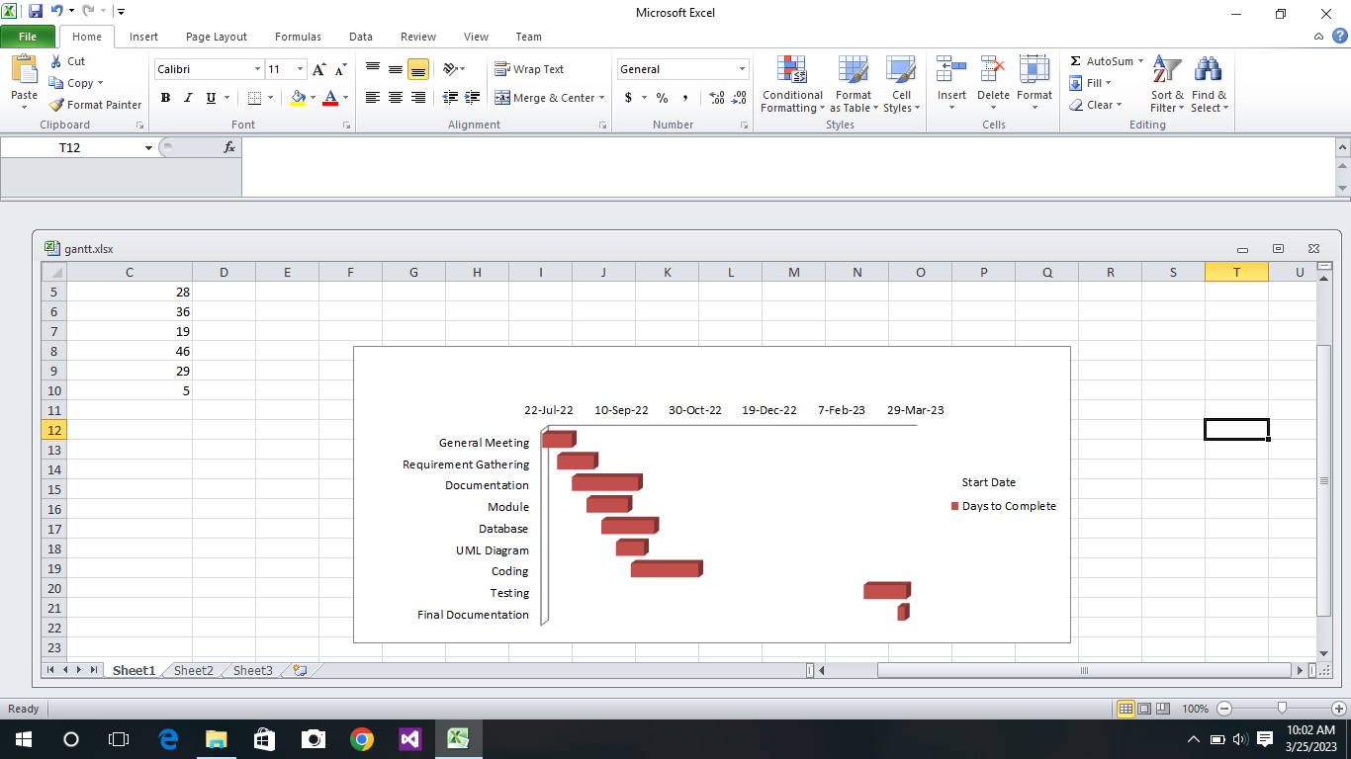

**3. SYSTEM DESIGN**

**3.1 Modules**

The system is basically divided into six modules as per the functionality they are as follows:

**Module 1.Login Module**

This module will help HR manager to login into the system using username and password. Here the user will be only HR Manager.

**Module 2.Department Module**

In this there are departments which are allotted in the company. Also it contains different types of post.

**Module 3.Recruitment Module**

When HR Manager checks the availability of vacant number .of post ,the work of doing recruitment process is stored in this field.

**Module 4.Employee Module**

This module stores all the details of assigned employee.

**Module 5. Training Module**

Training module contains details of training which is assigned to employee. All the details from the training start to end is stored.

**Module 6. Salary Module**

It only displays the total salary amount.

**3.2 DATABASE:**

1. **Login Table**

|  |  |  |  |
| --- | --- | --- | --- |
| **Column name** | **Description** | **Type** | **Constraint** |
| User_Name | Name of user accessing the system | Varchar(50) | Not Null |
| User_Password | Password of user | Int(10) | Not Null |

**Table1. Login Table**

1. **Recruitment Table**

|  |  |  |  |
| --- | --- | --- | --- |
| **Column Name** | **Description** | **Type** | **Constraint** |
| Recruitment_id | ID of recruitment | Int(10) | Primary Key |
| Post_id | ID of Post | Int(25) | Foreign Key |
| Total Number of Job  Vacancy | Number of vacant Post | Int(25) | Not Null |
| Date of Advertisement of vacant post | Advertisement release date | Date(55) | Not Null |
| Total number of  Resumes Received | Count of total resumes | Int(50) | Not Null |
| Date of Interview | Date of Interview | Date(10) | Not Null |
| Total number of  candidate attended interview | Count of candidate attended interview for that post | Int(25) | Not Null |
| Number of shortlist candidate | Selected candidate | Int(12) | Not Null |

**Table 2. Recruitment Table**

**3.Department Table**

|  |  |  |  |
| --- | --- | --- | --- |
| **Column Name** | **Description** | **Type** | **Constraint** |
| Department_id | ID of particular department | Int(11) | Primary Key |
| Department_name | Name of Department | Varchar(20) | Not Null |
| Department_location | Place where department is located (in which city) | Varchar(20) | Not Null |

**Table 3. Department Table**

**4.Post Table**

|  |  |  |  |
| --- | --- | --- | --- |
| **Column Name** | **Description** | **Type** | **Constraint** |
| Post_id | ID of post | Int(10) | Primary Key |
| Dept_id | ID of Department | Int(50) | Foreign Key |
| Post_Name | Name of Post | Varchar(100) | Not Null |
| Allotted Number of Employee | Total Number of allotted Employee | Int(150) | Not Null |
| Vacant Number of Post | Number of Vacant Post | Int(25) | Not Null |

**Table 4. Post Table**

**5. Employee Table**

|  |  |  |  |
| --- | --- | --- | --- |
| **Column Name** | **Description** | **Type** | **Constraint** |
| Employee_id | ID of Employee | Int(20) | Primary Key |
| Employee_FullName | Full Name of Employee | Varchar(50) | Not Null |
| Employee_Address | Address of employee | Varchar(50) | Not Null |
| Employee_PhoneNumber | Contact details | Int(25) | Not Null |
| Employee_Email | Email | Varchar(50) | Not Null |
| Employee_HireDate | Hiring Date | Date(10) | Not Null |
| Employee_PostId | Post id of assigned employee | Int(10) | Foreign Key |
| Employee_Gender | Gender | Varchar(25) | Not Null |
| Employee_BirthDate | Date of Birth | Date(20) | Not Null |
| Employee_TrainingName | Training Name | IVarchar(25) | Not Null |

**Table 5. Employee Table**

**6. Training Table**

|  |  |  |  |
| --- | --- | --- | --- |
| **Column Name** | **Description** | **Type** | **Constraint** |
| Training_Date | Training schedule | Date(20) | Not Null |
| Training_Completion Date | Duration of Training | Date(20) | Not Null |
| Employee_TrainingName | Name of the training | Varchar(5) | Not Null |
| Employee_ID | ID of the employee | Int(10) | Foreign Key |

**Table 6. Training Table**

**7. Salary Table**

|  |  |  |  |
| --- | --- | --- | --- |
| **Column Name** | **Description** | **Type** | **Constraint** |
| Salary_Basic | Starting salary of employee | Int(10) | Not Null |
| Salary_DA | Dearness Allowance | Number(20) | Not Null |
| Salary_HRA | House Rent Allowance | Number(20) | Not Null |
| Salary_Total | Total amount | Int(10) | Not Null |
| Employee_Full Name | Name of employee | Varchar(25) | Not Null |
| Employee_id | ID of employee | Int(50) | Foreign Key |

**Table 7. Salary Table**

**3.3 FIGURES:**

**3.3.1 ER DIAGRAM:**

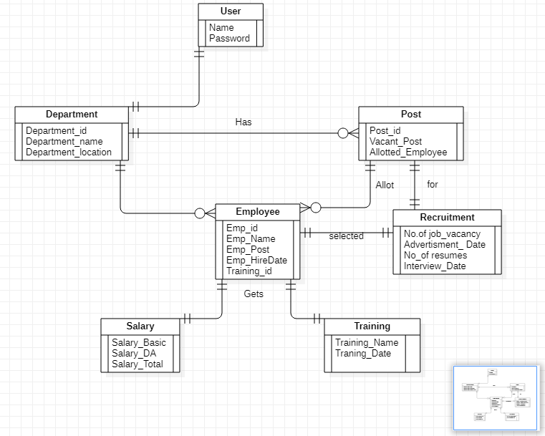

Fig 1. ER Diagram

**3.3.2 ACTIVITY DIAGRAM:**

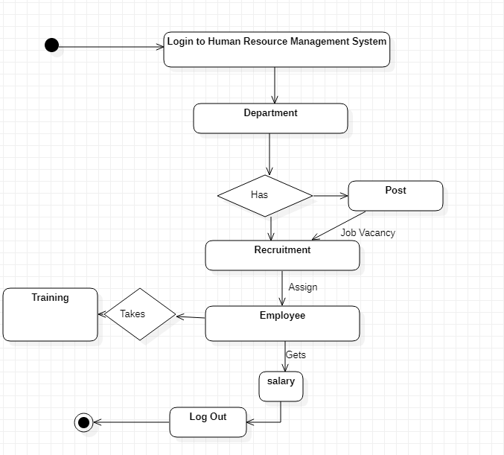

Fig 2. Activity Diagram

**3.3.3 SEQUENCE DIAGRAM:**

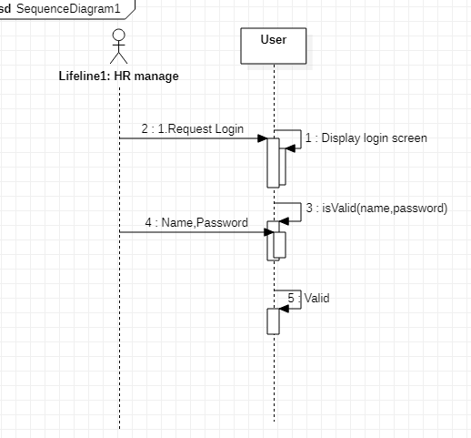

**sdccc**

Fig 3.1 Sequence Diagram for login

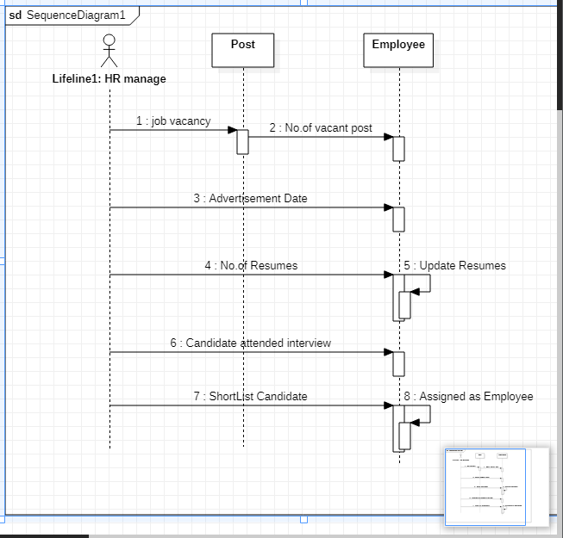

Fig. 3.2 Sequence Diagram for Recruitment

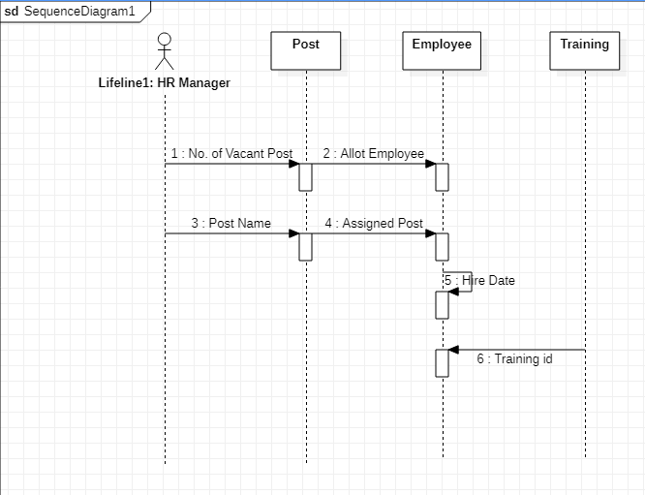

Fig 3.3 Sequence Diagram for Post and Employee

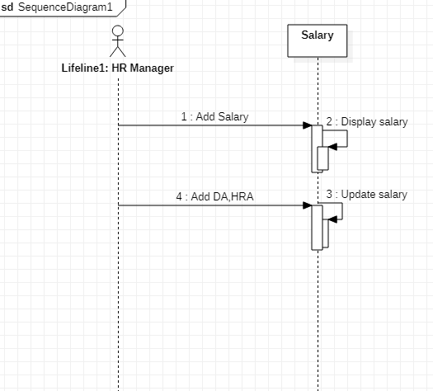

Fig.3.4 Sequence Diagram for Salary

**3.3.4 USE CASE DIAGRAM:**

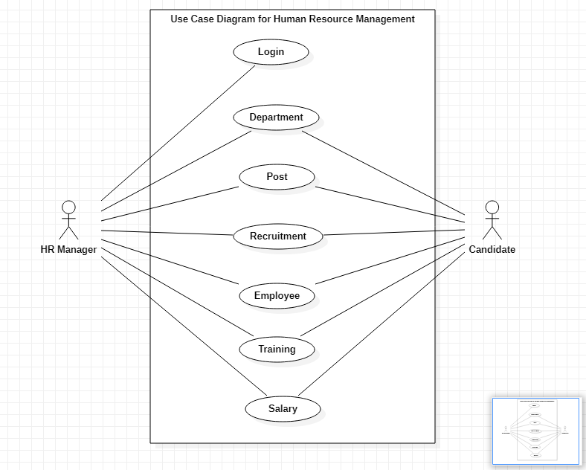

Fig 4.1 Use Case Diagram

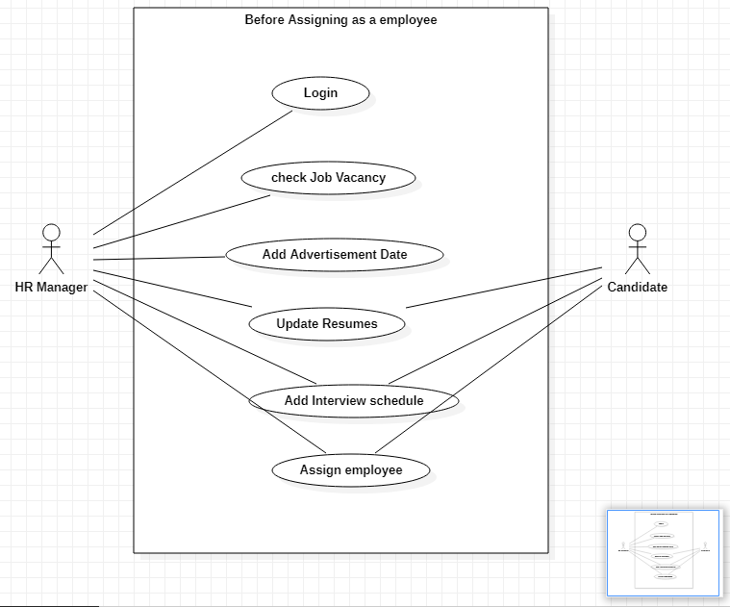

Fig 4.2 Before Assigning as a employee:



Fig 4.3 After Assigning as an Employee:

**3.3.5 CLASS DIAGRAM:**

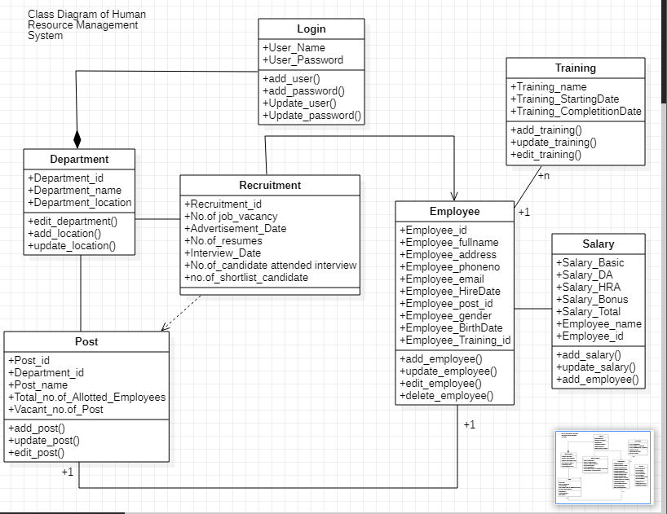

Fig 5. Class Diagram

**3.4 USER INTERFACE:**

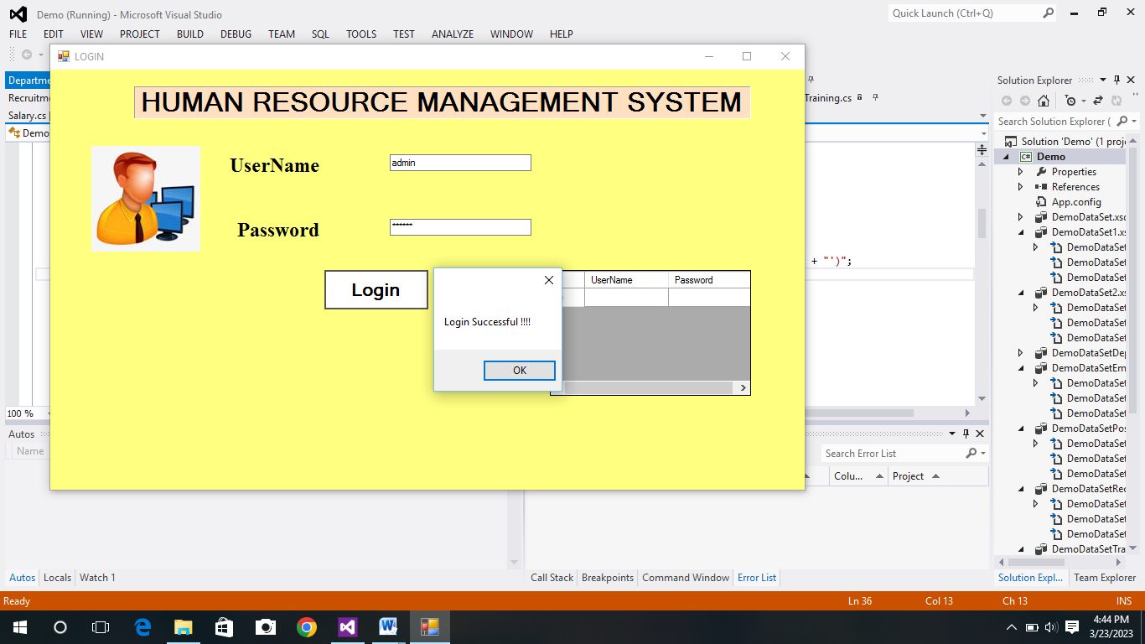

1. **Login Module**

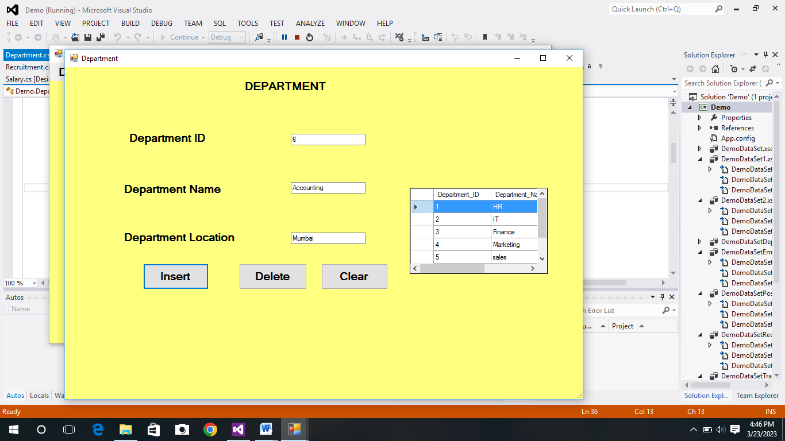

**2. Department Module**

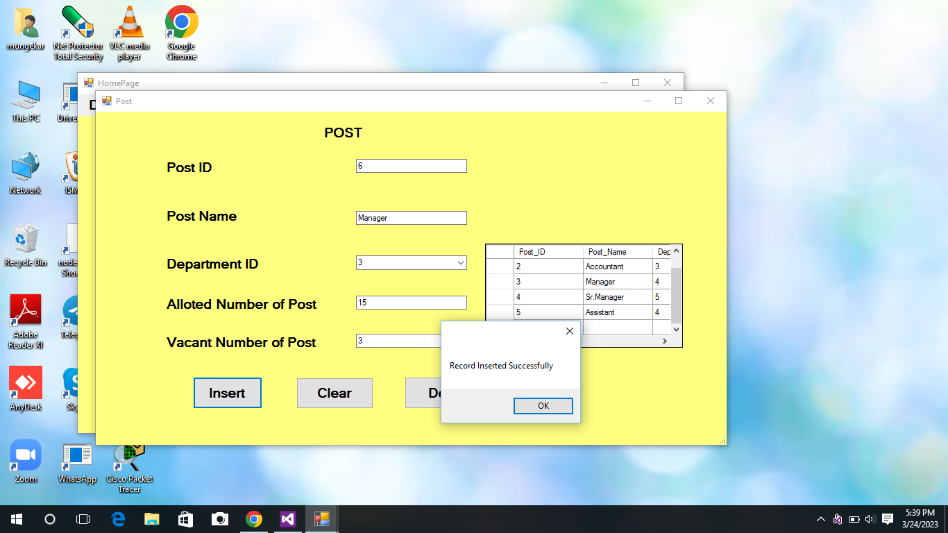

**3.Post Module**

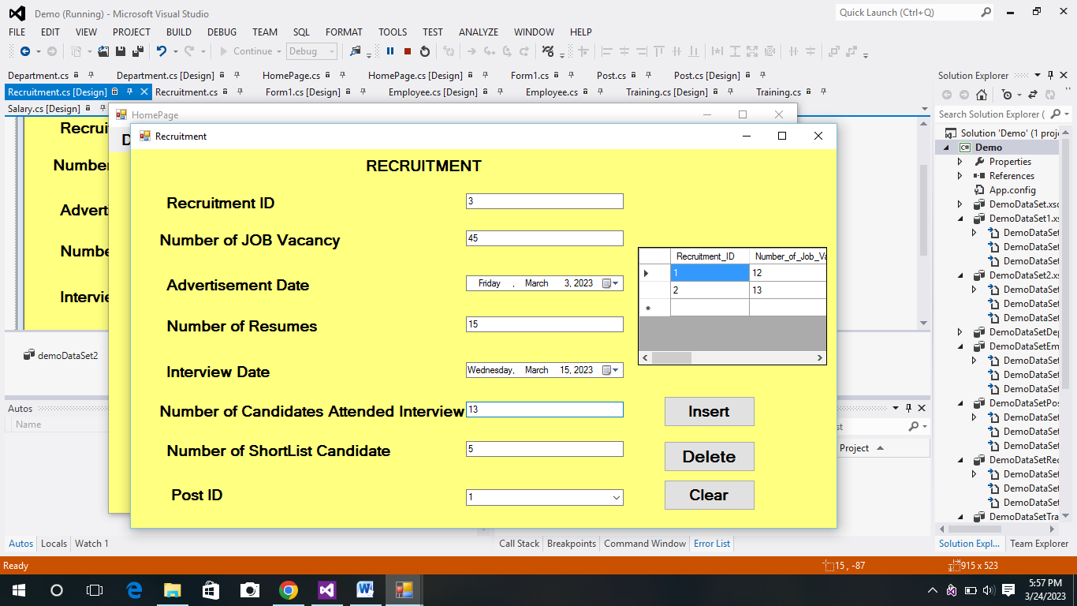

**4.Recruitment Module**

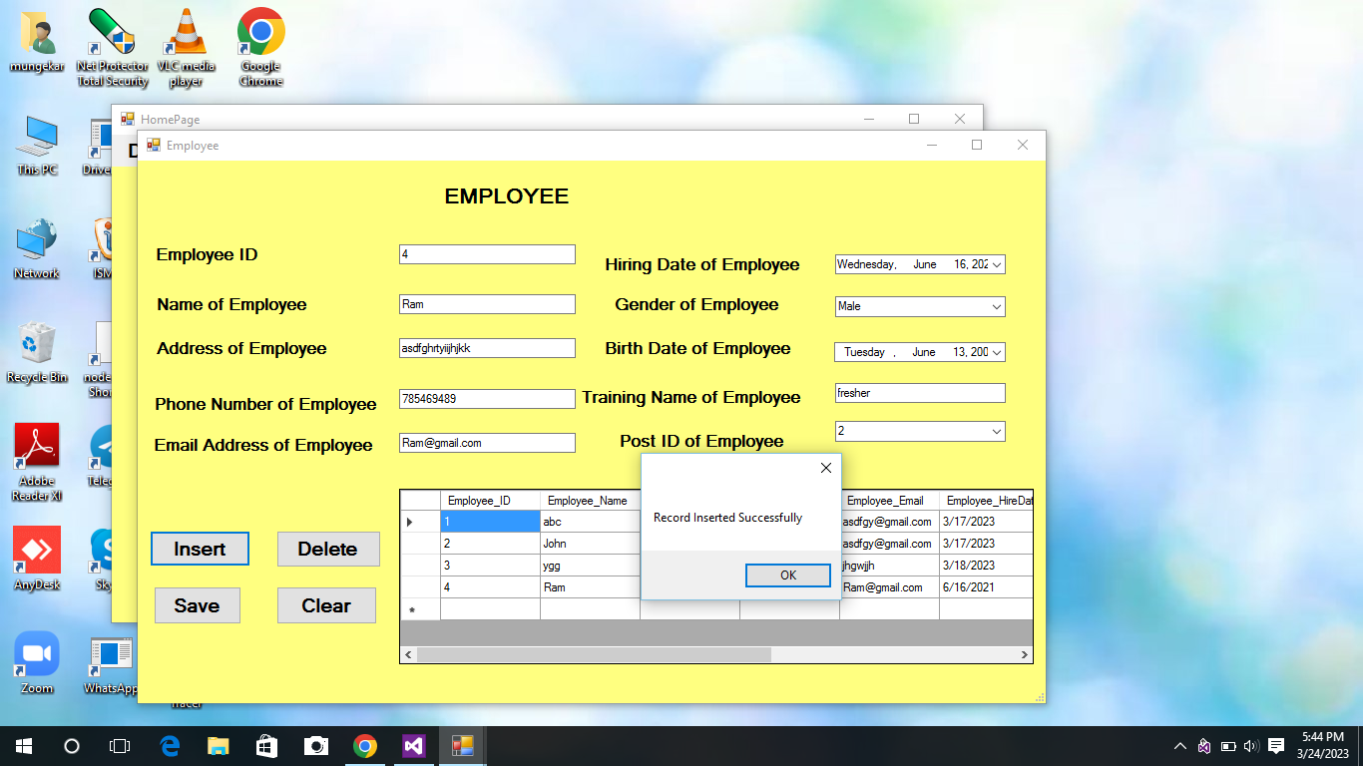

**5. Employee Module**

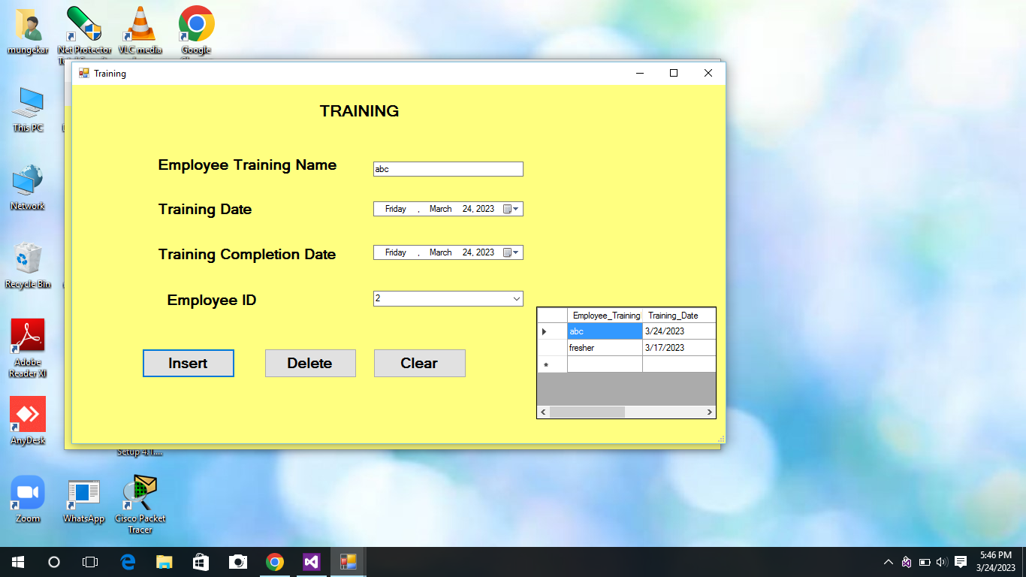

**6. Training Module**

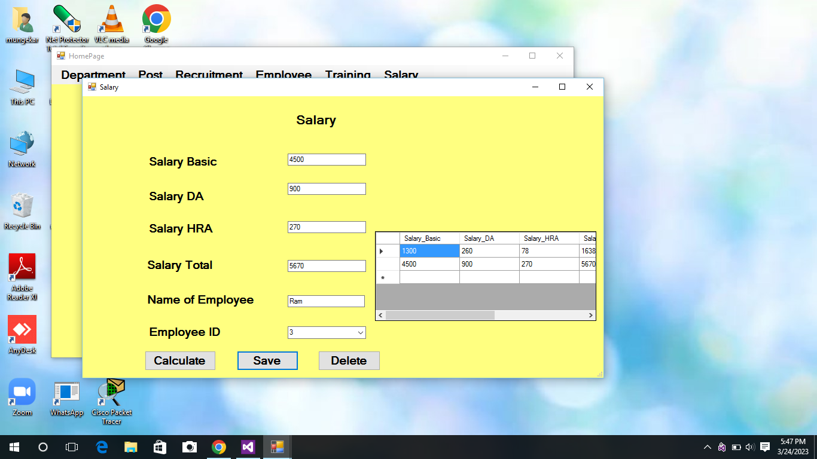

**7. Salary Module**

**4. IMPLEMENTATION AND TESTING**

**4.1 CODE:**

* **Department.cs**

namespace Demo

{

public partial class Department : Form

{

SqlConnection con = new SqlConnection(@"Data Source=(LocalDB)\v11.0;AttachDbFilename=E:\.net practicals\Demo\Demo.mdf;Integrated Security=True;");

public Department()

{

InitializeComponent();

}

private void btn_insert_Click(object sender, EventArgs e)

{

if (txt_ID.Text == "")

{

MessageBox.Show("Please Enter Department ID", "Error", MessageBoxButtons.OK, MessageBoxIcon.Error);

return;

}

MessageBox.Show("Record Inserted Successfully");

con.Open();

SqlCommand cmd = con.CreateCommand();

cmd.CommandType = CommandType.Text;

cmd.CommandText = "insert into Department_1 values('" + txt_ID.Text + "','" + txt_Name.Text + "','" + txt_Location.Text + "')";

cmd.ExecuteNonQuery();

con.Close();

disp_data();

}

* **Post.cs**

namespace Demo

{

public partial class Post : Form

{

SqlConnection con = new SqlConnection(@"Data Source=(LocalDB)\v11.0;AttachDbFilename=E:\.net practicals\Demo\Demo.mdf;Integrated Security=True;");

public Post()

{

InitializeComponent();

}

private void combo_DepartmentID_SelectedIndexChanged(object sender, EventArgs e)

{

MessageBox.Show(combo_DepartmentID.SelectedValue.ToString());

}

private void dataGridView1_CellClick(object sender, DataGridViewCellEventArgs e)

{

if (e.RowIndex >= 0)

{

txt_PostID.Text = dataGridView1.SelectedRows[0].Cells[0].Value.ToString();

txt_PostName.Text = dataGridView1.SelectedRows[0].Cells[1].Value.ToString();

combo_DepartmentID.Text = dataGridView1.SelectedRows[0].Cells[2].Value.ToString();

txt_AllotedPost.Text = dataGridView1.SelectedRows[0].Cells[3].Value.ToString();

txt_VacantPost.Text = dataGridView1.SelectedRows[0].Cells[4].Value.ToString();

}

}

* **Salary.cs**

namespace Demo

{

public partial class Salary : Form

{

SqlConnection con = new SqlConnection(@"Data Source=(LocalDB)\v11.0;AttachDbFilename=E:\.net practicals\Demo\Demo.mdf;Integrated Security=True;");

public Salary()

{

InitializeComponent();

}

private void btn_cal_Click(object sender, EventArgs e)

{

double m = double.Parse(txt_Basic.Text);

double n = double.Parse(txt_DA.Text);

double o = double.Parse(txt_HRA.Text);

double T = m + n + o;

txt_total.Text = T.ToString();

}

private void txt_Basic_TextChanged(object sender, EventArgs e)

{

Double a = Double.Parse(txt_Basic.Text);

double b;

double c;

b = a * 0.20;

c = a * 0.06;

txt_DA.Text = b.ToString();

txt_HRA.Text = c.ToString();

}

**4.2 TEST CASES:**

|  |  |  |  |  |  |
| --- | --- | --- | --- | --- | --- |
| **Sr.no** | **Test case name** | **Possible Input** | **Expected Result** | **Actual Result** | **Conclusion** |
| 1 | Login | Valid username and/or password. | Login successful Redirect to home page | Login successful | Pass |
| Invalid username and /or password. | Username and / or password is incorrect message box | Username and / or password is incorrect message box | Pass |
| 2 | Department | ValiValid Data Inserted  Ins | Data Inserted | Data Inserted | Pass |
| Empty Field | Enter Department ID message box | Enter Department ID message box | Pass |
| 3 | Post | All valid details  Filled | Data Inserted successfully | Data Inserted successfully | Pass |
| Empty Field | Enter Post ID message box | Enter Post ID message box | Pass |
| 4 | Recruitment | All valid details filled | Data Inserted successfully | Data Inserted successfully | Pass |
| Empty Field | Enter Recruitment ID message box | Enter Recruitment ID message box | Pass |
| 5 | Employee | All valid details filled  Birth Date not valid | Data Inserted  Age should be greater than 18 | Age should be greater than 18 | Pass |
| Empty Field | All fields are mandatory | All fields are mandatory | Pass |
| 6 | Training | AlValid details filled | Data Inserted Successfully | Data Inserted successfully | Pass |
| Empty Field | Fill all mandatory Fields | Fill all mandatory Fields | Pass |
| 7 | Salary | Valid Data | Display total salary | Display total salary | Pass |

5. **RESULT AND DISCUSSION**

* **Login Form:**
* It is the first form which appears on the screen.
* In this form user needs to login with correct Username and Password.

-Username: admin

-Password: 123456

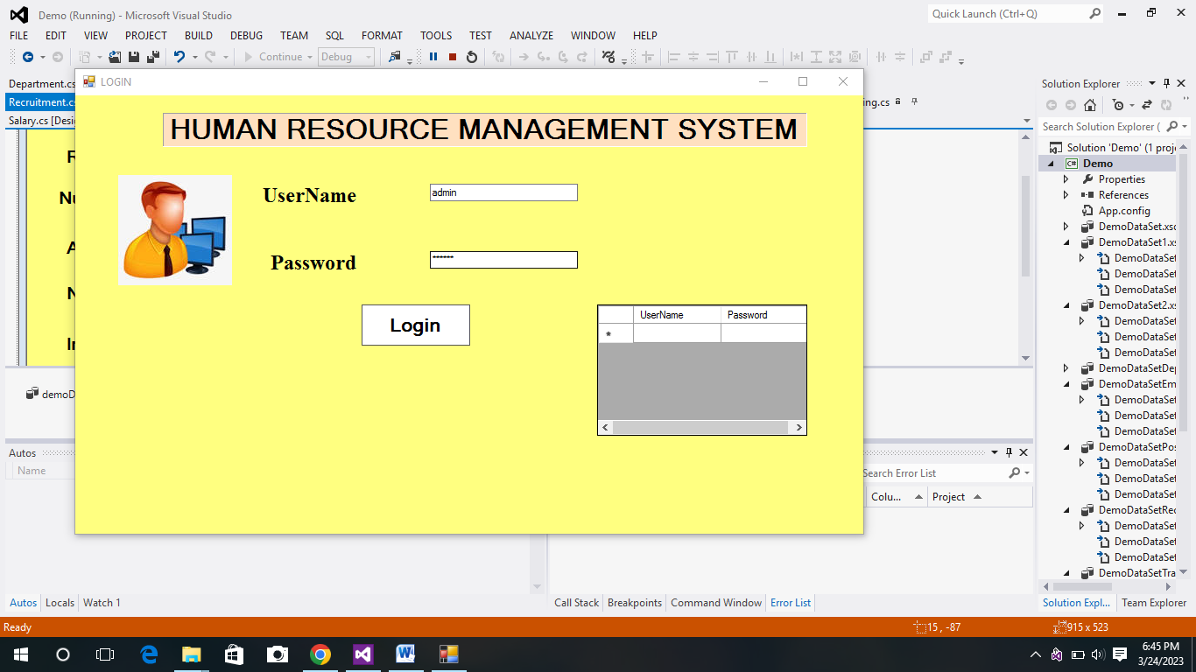

* **Home Page:**
* It is the Home page of the system which consists list of all modules.
* From here the admin (HR Manager) can select any module which he/she want to visit.

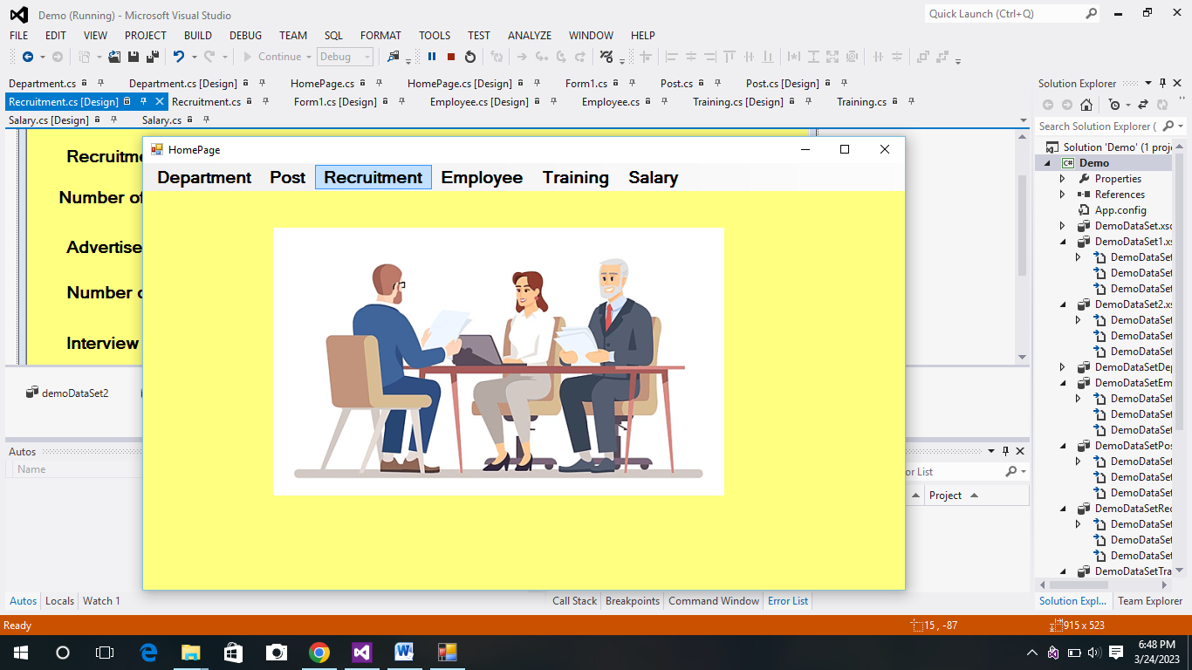

* **Recruitment Form:**
* HR manager will look into the number of vacant post in post module and then the recruitment process will take place.
* All the details of recruitment like Advertisement Date, Interview Date, No. of candidate attended interview, shortlisted candidate this data of particular candidate will be saved here.
* Just need to fill all the mandatory fields and click on insert button .
* Also for deleting , use delete button to delete it

.



* **Employee Form:**
* Once the Candidate is assigned as an employee, all the personal details related to them will be filled here.
* Click on Employee module from home page, then fill all the mandatory fields and save the data.
* If any one of the field is kept blank then the data cannot be saved and also it cannot be inserted into database.



**6. CONCLUSION**

HR Manager is the most important role in any organization. To carry out tasks like from recruiting an individual to their salary all the tasks which comes under this process has to be handled by HR Manager. So for betterment of organization and to do task easier this system can be useful.

It can help the organization to save time, cost and energy in their operations and management. This system provides a large database for the organization to store and maintain all the information and to take certain kinds of decisions.

7. **REFERENCE**

* [www.google.com](http://www.google.com)
* [www.geeksforgeeks.com](http://www.geeksforgeeks.com)
* [www.youtube.com](http://www.youtube.com)